Exercice 1 :

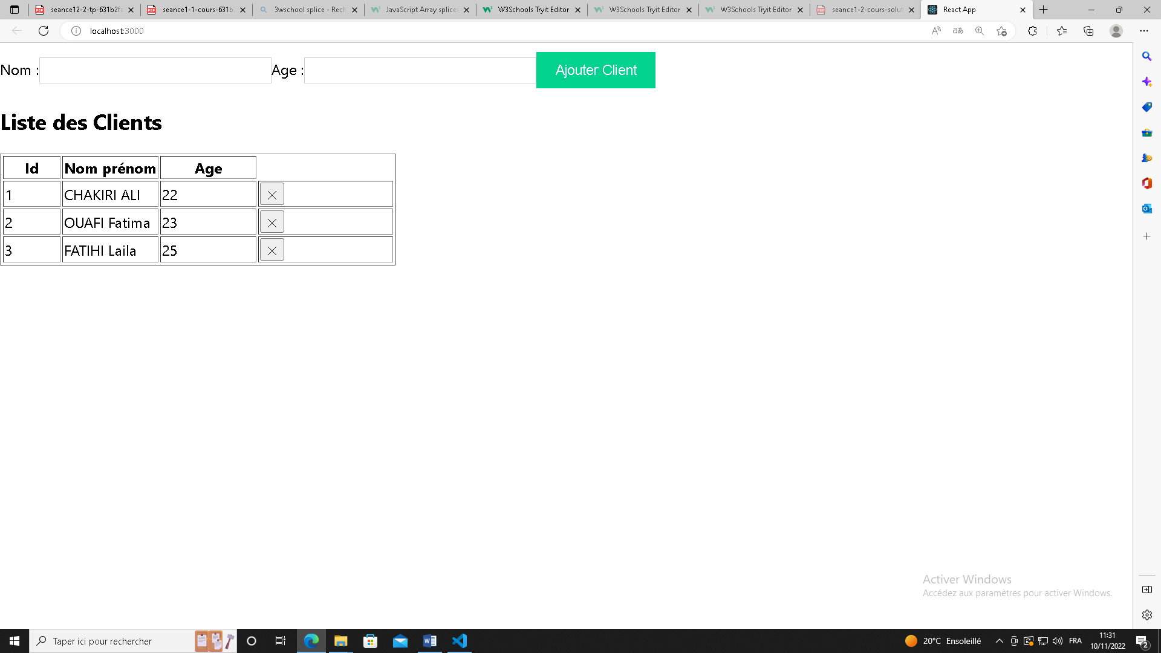

import React from "react";

import ReactDOM, { createRoot } from 'react-dom/client';

import reportWebVitals from './reportWebVitals';

import './index.css';

 class Clients extends React.Component{

constructor(props){

  super(props)

  this.state={ListeClients:[{id:1,nom:"CHAKIRI ALI",age :22},{id:2,nom:"OUAFI Fatima",age:23},{id:3,nom:"FATIHI Laila",age:25}],Tnom:'',Tage:'',Tid:4}

}

AjouerClient=(e)=>{

e.preventDefault();

this.setState({Tid:this.state.Tid+1})

console.log(this.state.Tid)

/\*const tClient2=[...this.state.ListeClients,{id:this.state.Tid,nom:this.state.Tnom,age:this.state.Tage}]

 this.setState({ListeClients:tClient2})\*/

 this.state.ListeClients.splice(this.state.Tid-1,0,{id:this.state.Tid,nom:this.state.Tnom,age:this.state.Tage})

 this.setState({Tnom:'',Tage:''})

}

supprimer=(id1)=>{

  const index=this.state.ListeClients.findIndex(client=>client.id==id1)

  console.log(index)

  const ListeClients2=[...this.state.ListeClients]

  ListeClients2.splice(index,1)

this.setState({ListeClients:ListeClients2})

 }

render(){

  const LClient=this.state.ListeClients.map((client)=>(<tr key={client.id}><td >{client.id}</td><td > {client.nom} </td><td >{client.age}</td>

  <td><button onClick={()=>{this.supprimer(client.id)}}>&#10005;</button></td></tr>))

  return(<div>

<form onSubmit={this.AjouerClient}>

Nom :<input type="Text" value={this.state.Tnom}   onChange={(e)=>this.setState({Tnom:e.target.value})}></input>

Age :<input type="Text"  value={this.state.Tage}   onChange={(e)=>this.setState({Tage:e.target.value})}></input>

<input type ="submit" value="Ajouter Client"></input>

    <h2>Liste des Clients</h2><table border="1"><tr><th width="15%">Id</th><th width="25%">Nom prénom</th><th width="25%">Age</th></tr>{LClient}

    </table>    </form></div>)

}

 }

const root = ReactDOM.createRoot(document.getElementById('root'));

root.render(

<Clients/>

);

// If you want to start measuring performance in your app, pass a function

// to log results (for example: reportWebVitals(console.log))

// or send to an analytics endpoint. Learn more: https://bit.ly/CRA-vitals

reportWebVitals();

Exercice 2 :

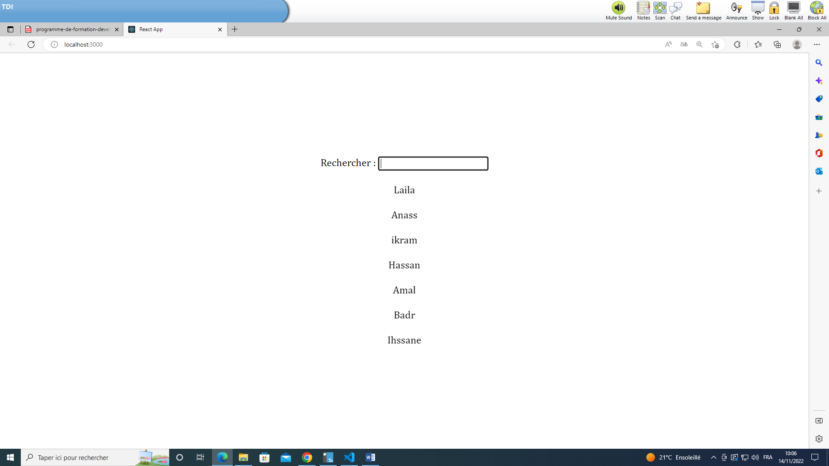

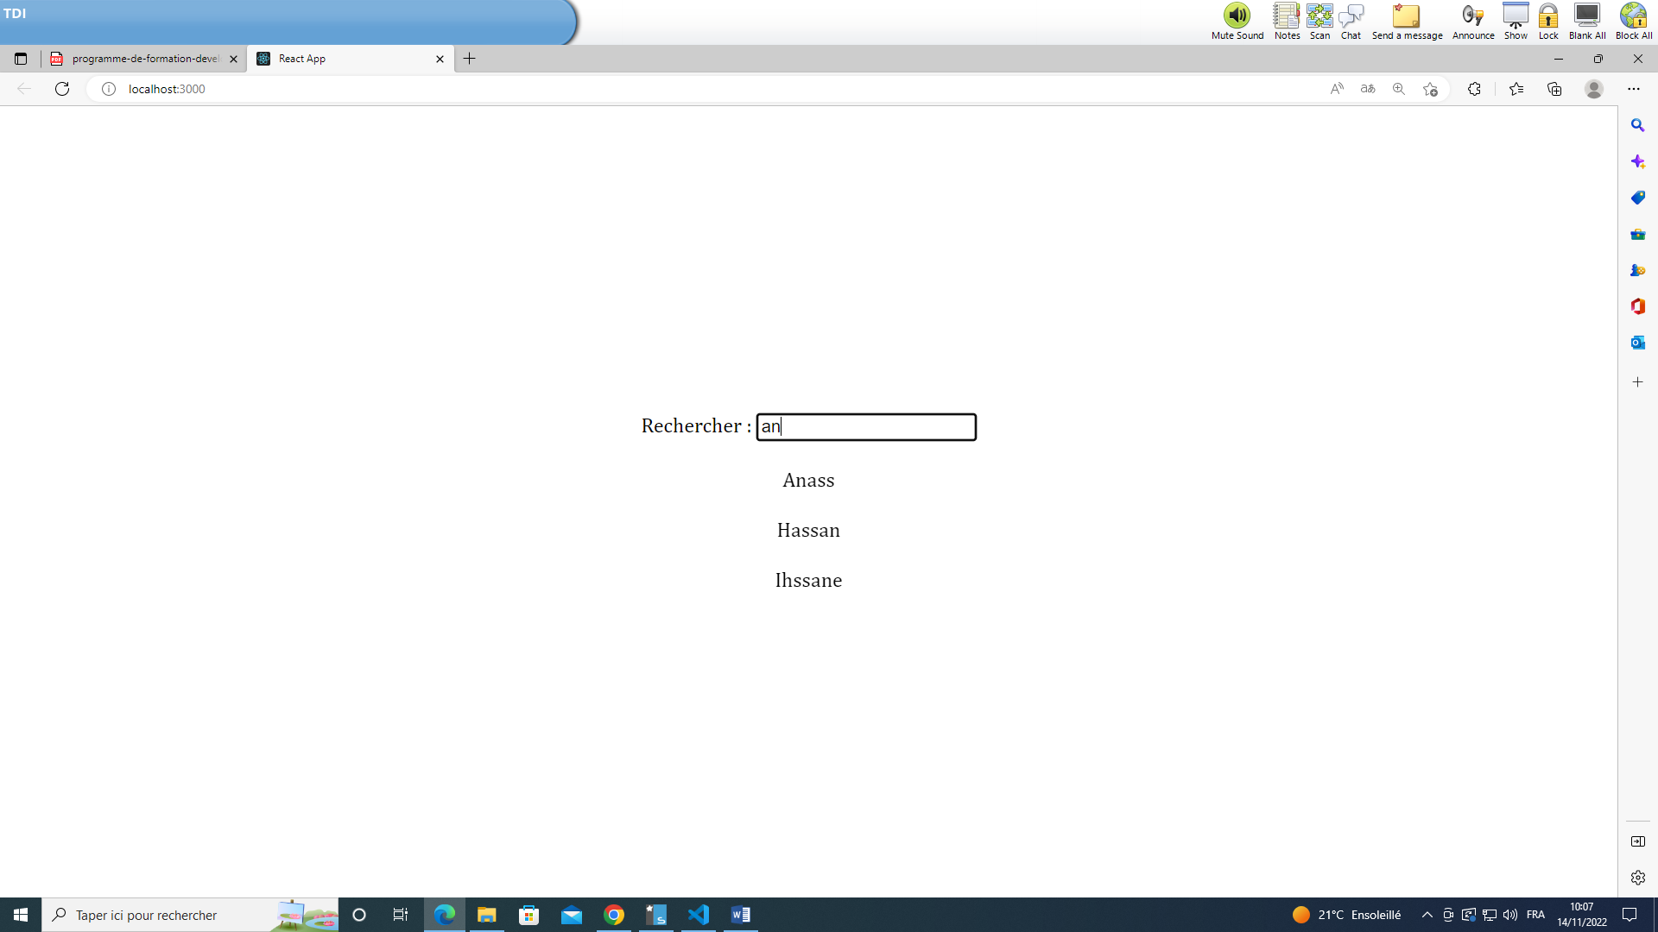

import React, { useState } from "react";

import ReactDOM, { createRoot } from 'react-dom/client';

import reportWebVitals from './reportWebVitals';

import './index.css';

function Recherche() {

  const listNoms = ["Laila","Anass","ikram","Hassan","Amal","Badr","Ihssane"];

  const [list, setList] = useState(listNoms);

  const Rechercher = (e) => {

    if (e.target.value === "") {

      setList(listNoms);

      return;

    }

    const ListRech = listNoms.filter((nom) => nom.toLowerCase().search(e.target.value.toLowerCase()) !== -1);

    setList(ListRech);

  };

  return (

    <div className="app">

      <div>

        Rechercher : <input  type="text" onChange={Rechercher} ></input>

      </div>

      {

        list.map((nom) => (

          <div >{nom}</div>

        ))}

    </div>

  );

}

const root = ReactDOM.createRoot(document.getElementById('root'));

root.render(

<Recherche/>

);

// If you want to start measuring performance in your app, pass a function

// to log results (for example: reportWebVitals(console.log))

// or send to an analytics endpoint. Learn more: https://bit.ly/CRA-vitals

reportWebVitals();

Exercice 3

––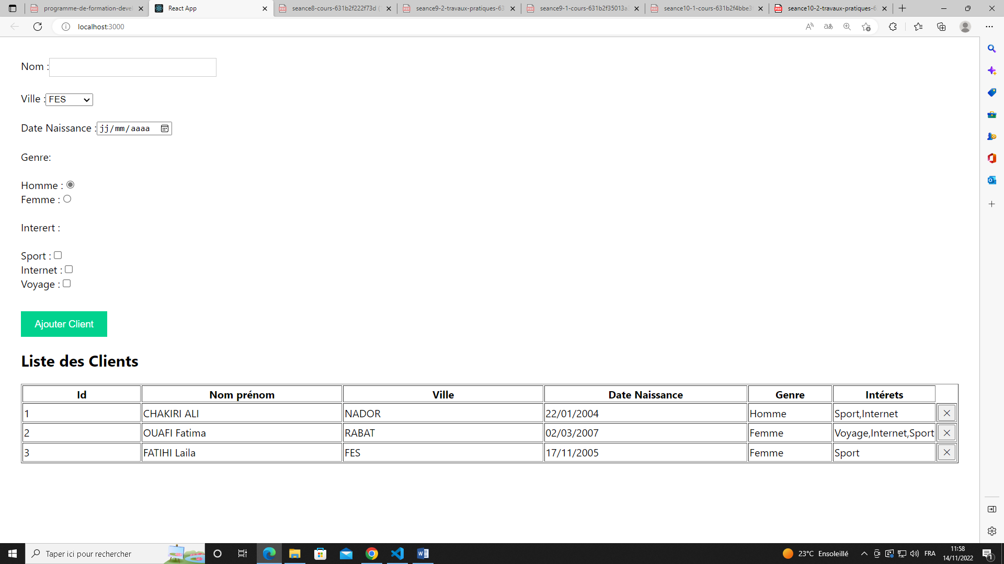

import React from "react";

import ReactDOM, { createRoot } from 'react-dom/client';

import reportWebVitals from './reportWebVitals';

import './index.css';

 class Clients extends React.Component{

constructor(props){

  super(props)

  this.state={ListeClients:[{id:1,nom:"CHAKIRI ALI",ville:"NADOR",dateN:"22/01/2004",genre:"Homme",interet:"Sport,Internet"},{id:2,nom:"OUAFI Fatima",ville:"RABAT",dateN:"02/03/2007",genre:"Femme",interet:"Voyage,Internet,Sport"},{id:3,nom:"FATIHI Laila",ville:"FES",dateN:"17/11/2005",genre:"Femme",interet:"Sport"}],Tnom:'',Tville:'',TN:'',Tgenre:'Homme',Tinteret:'',Tid:4}

}

AjouerClient=(e)=>{

e.preventDefault();

this.setState({Tid:this.state.Tid+1})

console.log(this.state.Tid)

/\*const tClient2=[...this.state.ListeClients,{id:this.state.Tid,nom:this.state.Tnom,age:this.state.Tage}]

 this.setState({ListeClients:tClient2})\*/

 this.state.ListeClients.splice(this.state.Tid,0,{id:this.state.Tid,nom:this.state.Tnom,dateN:this.state.TN,ville:this.state.Tville,genre:this.state.Tgenre,interet:this.state.Tinteret})

 this.setState({Tnom:'',TN:'',Tville:'',Tinteret:''})

}

supprimer=(id1)=>{

  const index=this.state.ListeClients.findIndex(client=>client.id==id1)

  console.log(index)

  const ListeClients2=[...this.state.ListeClients]

  ListeClients2.splice(index,1)

this.setState({ListeClients:ListeClients2})

 }

render(){

  const LClient=this.state.ListeClients.map((client)=>(<tr key={client.id}><td >{client.id}</td><td > {client.nom} </td><td > {client.ville} </td><td >{client.dateN}</td><td >{client.genre}</td><td >{client.interet}</td>

  <td><button onClick={()=>{this.supprimer(client.id)}}>&#10005;</button></td></tr>))

  return(

    <div className="login-form">

<form onSubmit={this.AjouerClient}>

Nom :<input type="Text" value={this.state.Tnom}   onChange={(e)=>this.setState({Tnom:e.target.value})}></input><br></br><br></br>

Ville :<select value={this.state.Tville}   onChange={(e)=>this.setState({Tville:e.target.value})}><br></br><br></br>

  <option value="FES">FES</option>

  <option value="Rabat">Rabat</option>

  <option value="Tanger">Tanger</option>

  <option value="Casa">Casa</option>

  <option value="NADOR">NADOR</option>

</select><br></br><br></br>

Date Naissance :<input type="date"  value={this.state.TN}   onChange={(e)=>this.setState({TN:e.target.value})}></input><br></br><br></br>

Genre: <br></br><br></br>

     Homme :<input type="radio" name="tg" value="Homme"   onChange={(e)=>this.setState({Tgenre:e.target.value})} checked></input><br></br>

    Femme :<input type="radio" name="tg" value="Femme"   onChange={(e)=>this.setState({Tgenre:e.target.value})}></input>

<br></br><br></br>

Interert :<br></br><br></br>

Sport    :<input type="checkbox" name="tinter" value="Sport"   onChange={(e)=>this.setState({Tinteret:this.state.Tinteret+' '+e.target.value})}></input><br></br>

Internet :<input type="checkbox" name="tinter" value="Internet"   onChange={(e)=>this.setState({Tinteret:this.state.Tinteret+' '+e.target.value})}></input><br></br>

Voyage   :<input type="checkbox" name="tinter" value="Voyage"   onChange={(e)=>this.setState({Tinteret:this.state.Tinteret+' '+e.target.value})}></input>

<br></br><br></br>

<input type ="submit" value="Ajouter Client"></input>

    <h2>Liste des Clients</h2><table border="1"><tr><th width="15%">Id</th><th width="25%">Nom prénom</th><th width="25%">Ville</th><th width="25%">Date Naissance</th><th width="25%">Genre</th><th width="25%">Intérets</th></tr>{LClient}

    </table>    </form></div>)

}

 }

const root = ReactDOM.createRoot(document.getElementById('root'));

root.render(

<Clients/>

);

// If you want to start measuring performance in your app, pass a function

// to log results (for example: reportWebVitals(console.log))

// or send to an analytics endpoint. Learn more: https://bit.ly/CRA-vitals

reportWebVitals();

Exercice 4

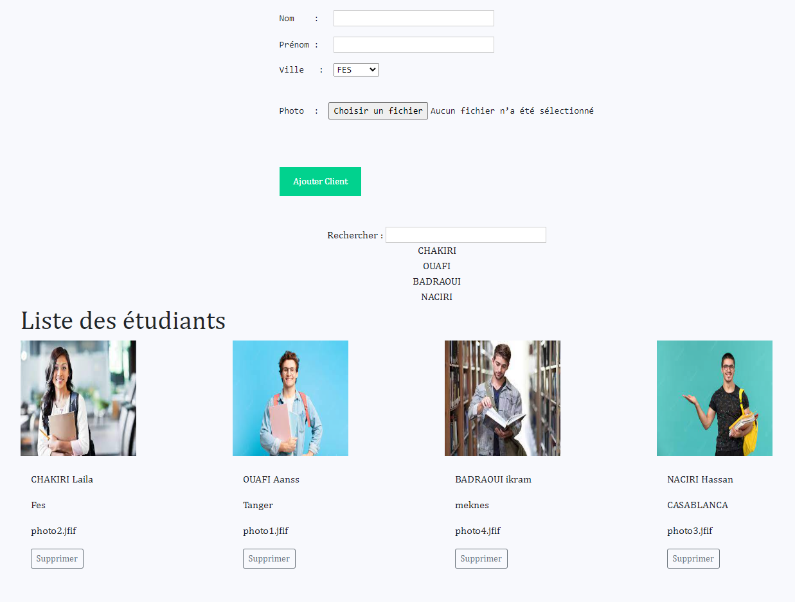

import React, { useState } from "react";

import ReactDOM, { createRoot } from 'react-dom/client';

import reportWebVitals from './reportWebVitals';

import './index.css';

function Recherche() {

  const listEtudi = [{nom:"CHAKIRI",prenom:"Laila",Ville:"Fes",photo:"photo2.jfif"},{nom:"OUAFI",prenom:"Aanss",Ville:"Tanger",photo:"photo1.jfif"},{nom:"BADRAOUI",prenom:"ikram",Ville:"meknes",photo:"photo4.jfif"},{nom:"NACIRI",prenom:"Hassan",Ville:"CASABLANCA",photo:"photo3.jfif"}];

  const [list, setList] = useState(listEtudi);

  const [nomE,setNomE]=useState('');

const [preE,setPreE]=useState('');

const [villeE,setVilleE]=useState('');

const [photoE,setPhotoE]=useState('');

  const AjouerClient=(e)=>{

    e.preventDefault();

    /\*const tEtud2=[...listEtudi,{nom:nomE,prenom:preE,ville:villeE,photo:photoE}]

    setList(tEtud2)\*/

    list.splice(1,0,{nom:nomE,prenom:preE,ville:villeE,photo:photoE})

     setNomE('');

      setPreE('');

      setVilleE('');

    }

  const Rechercher = (e) => {

    if (e.target.value === "") {

      setList(listEtudi);

      return;

    }

    const ListRech = listEtudi.filter((etud) => etud.nom.toLowerCase().search(e.target.value.toLowerCase()) !== -1);

    setList(ListRech);

  };

  return (

    <div className="app">

<div>

<form onSubmit={AjouerClient}>

<pre>Nom    :   <input type="Text" value={nomE}   onChange={(e)=>{setNomE(e.target.value)}}  ></input><br></br></pre>

<pre>Prénom :   <input type="Text" value={preE}   onChange={(e)=>{setPreE(e.target.value)}}  ></input></pre>

<pre>Ville   :  <select value={villeE}  onChange={(e)=>{setVilleE(e.target.value)}} >

  <option value="FES">FES</option>

  <option value="Rabat">Rabat</option>

  <option value="Tanger">Tanger</option>

  <option value="Casa">Casa</option>

  <option value="NADOR">NADOR</option>

</select></pre><br></br>

<pre>Photo  :  <input type="file" value={photoE}  onChange={(e)=>{setPhotoE(e.target.value)}} ></input></pre>

<br></br><br></br>

<input type ="submit" value="Ajouter Client"></input>

</form>

</div>

<br></br><br></br>

      <div>

        Rechercher : <input  type="text" onChange={Rechercher} ></input>

      </div>

      {

        list.map((etud) => (

          <div >{etud.nom}</div>

        ))}

<main className="container">

              <h1>Liste des étudiants </h1>

              <div className="row mb-2">

              {list.map((etud) => (

     <div className="col">

     <div className="">

       <img className="" height={180} width="180px" src={etud.photo}  alt="" />

       <div className="card-body">

         <p className="card-title"></p>

                <p className="card-text">{etud.nom + '    '+etud.prenom}</p>

                <p className="card-text">{etud.Ville}</p>

                <p className="card-text">{etud.photo}</p>

                    <button type="button"  className="btn btn-sm btn-outline-secondary">Supprimer</button>

                    </div>

                </div>

              </div>

        ))}

         </div>

        </main>

   </div>

  );

}

const root = ReactDOM.createRoot(document.getElementById('root'));

root.render(

<Recherche/>

);